## Assignment 1 Report: HTML5 and My Favourite Movie

Elizabeth Reid (41071602)

February 6th, 2023

LIB 2024 – Internet Applications

Prof.: Dr. Huthaifa Abderahman

### Table of Contents

1. Introduction page 1
2. List of Elements and Tricks Used page 1
3. Script Blocks and Comments page 2
4. SEO Standards page 5
5. Conclusion page 5
6. References page 6

### Introduction

In order to recreate the given screenshot of the basic HTML page, I wanted to first list all the tags and elements that I could identify. In order to ensure that the tags were all functional, I copied the opening tags, found in the first screenshot under **Script Blocks and Comments**, and ensured that basic text, such as webpage title and header appeared as desired.

From here, it was just a matter of adding and formatting tags in the script blocks as needed. These tags, which are listed in the **List of Elements and Tricks Used** and further explained under Script Blocks and Comments, all contained the different text required to display on the webpage, including the description, reviews, quotes, and more from the movie.

### List of Elements and Tricks Used

The following tags are in order of use in the HTML file.

**<html>**

This tag indicates the format of the code being read by the web browser.

**<img>**

Used to insert images via link or file path.

**<head>**

Used to indicate the section of the code housing the title of the webpage.

**<title>**

Used to establish the title of the webpage.

**<body>**

Used to indicate the main body of the webpage’s content.

**<header>**

Used to indicate the placement of a section containing an <h#> tag.

**<h1>, <h2>, <h3>, etc.**

Used to emphasize plain text to make a header.

**<main>**

Used to indicate the main section of the webpage’s content and organize the HTML code into sections.

**<section>**

Used to organize HTML code into sections, making it easier to follow and understand.

**<article>**

Used to indicate a section designated for an article.

**<p>**

Used to insert plain text in paragraph form.

**<ul>**

Used to create an unordered list with given values.

**<progress>**

Used to indicate progress on a bar with given full and progress values.

**<mark>**

Used with <p> tag to highlight plain text in the <p> tag.

**<footer>**

Creates plain text at the bottom of the page, used to add additional text outside of the main section.

### Script Blocks and Comments

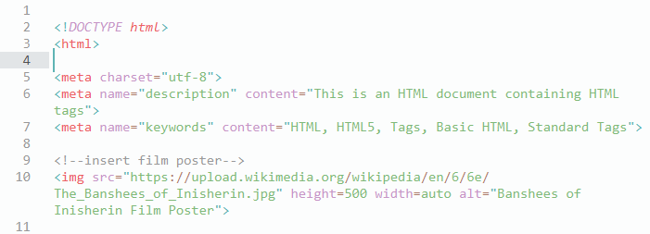

This block of script introduces the format found within this script by using <!DOCTYPE html> and opens the <html> tag that encompasses the entire script.

This section of my code includes the <head> and <title> tags, creating the title of the webpage displayed in the browser. This title briefly explains what the content on the page will be talking about, without being so long that it would not display on a browser’s tab bar.

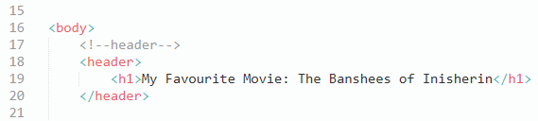

This section of my script includes the opening <body> tag, as well as the complete <header> and <h1> tags. The body tag indicates the beginning of the body content of the webpage, and the <header> tags show that this section houses the title displayed on the webpage. <h1> takes the plain text included in the script, in this case “My Favourite Movie: The Banshees of Inisherin” and displayed it on the webpage in a heading style. This becomes the title of the webpage, displayed with slightly more detailed than its <title> counterpart.

This section of the script contains the opening <main> tag and entire <section>, <article>, and <p> tags. The <main> tag indicates the beginning of the main portion of content displayed on the webpage, in this case right after the title. The <section> and <article> tags generally separates this content from the rest of the script in order to make the script easier to navigate and look more appealing. The <p> tag inserts the plain text included in the script onto the website in paragraph form. In this case, this tag creates a description of The Banshees of Inisherin directly under the webpage’s title.

This section makes use of another <section> and <h2> tag. In order to create a non-ordered list of cast members, I used the <ul> tag separated by line to better visualized the script.

This section uses no new tags, but again makes use of the <section>, <h3>, and <p> tags.

This black of script uses the same tags and elements as previous sections, excluding the new use of the <progress> tag. I used this tag in order to visualize the ratings given to this film by my friends and family. The max=”10” creates a maximum value of 10 while the value=”#” means that a certain percentage of the bar is covered, according to the percentage of that number in relation to the maximum value.

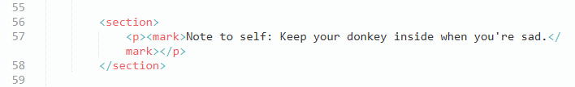

The only new element in this block of script is the <mark> tag, which modifies the text within the <p> tag in order to highlight it, in this case in yellow.

This section features a <footer> tag, which creates a plain text final comment at the foot of the webpage. This block of script also closes several of the overall tags encompassing the entire or a large part of the script by using </body> and </html>.

### SEO Standards

In order to comply with SEO standards, I double checked my tags to ensure they were complying wherever possible and needed. In this specific script, the headings tags in particular comply by all having a unique identifier. Each one is labelled with an ascending number, such as <h1>, then <h2>, and so forth. SEO standards also state that <h1> should identify the most important heading on the page, therefore I included the main title of the page in this tag.

Staying with the title, I made sure to limit the title to below 65 characters, making it quick and easy to read and identify as the title of the webpage, while still relevant to the content of the page and interesting enough to convince users to visit the site.

### Conclusion

In conclusion, this script includes basic HTML tags and elements as a way to showcase the content included in the code as plain text with some minor modifications. Using tags such as <header> and its subsequent <h1>, <h2>, etc. some content was emphasized, while tags like <p>, <mark>, and <ul> allowed for the information that was given to be displayed in various formats.

Though there were no errors in running this code, as HTML processors generally work to fix any small mistakes, this webpage would need further code to make it more appealing and more interactive. The webpage that is created via this code is therefore very basic and somewhat easy to replicate from a picture of the product alone.

### References

*HTML Basic Examples*. W3Schools. (n.d.). Retrieved February 1, 2023, from https://www.w3schools.com/html/html_basic.asp

*HTML Lists*. W3Schools. (n.d.). Retrieved February 1, 2023, from https://www.w3schools.com/html/html_lists.asp

Wikimedia Foundation. (n.d.). *The Banshees of Inisherin*. Wikipedia. Retrieved February 1, 2023, from https://en.wikipedia.org/wiki/The_Banshees_of_Inisherin